

Health Benefits Update  
Form 10-10EZ

Version 1  
Last Modified: November 15, 2023

Table of Contents

Update health benefits form Overview and Navigation 3

Update health benefits form Introduction Page 6

Signed in users: LOA1 (not identity verified) 8

Signed in users: LOA3 (identity verified) 10

Filling Out the update health benefits form 13

Veteran Information 16

Veteran information page 1: Names 16

Veteran information page 2: Mailing address 16

Veteran information page 3: Email and phone number 20

Household Information 21

Household information page 1: Marital status 21

Household information page 2: Spouse’s personal information 21

Household information page 3: Spouse’s additional information 23

Household information page 4: Spouse’s financial support 24

Household information page 5: Dependent’s information 24

Household information page 6: Dependent’s personal information 26

Household information page 7: Dependent’s education expenses 28

Household information page 8: Dependent’s additional information 29

Household information page 9: Dependent’s annual income (previous year) 30

Household information page 10: Review your dependents 32

Household information page 11: Annual income 33

Household information page 12: Previous calendar year deductible expenses 34

Insurance Information 35

Insurance information page 1: Medicaid 35

Insurance information page 2: Medicare 35

Insurance information page 3: Medicare detail 36

Insurance information page 4: Other coverage 38

Review form 41

Update health benefits form Issues 48

Questions about the content of the form 48

form is pre-filled with incorrect information 48

Veteran can’t move forward in their form 48

Veteran is having trouble upgrading their LOA1 account to an LOA3 account 49

# 

# Update Health Benefits Overview and Navigation

Users of VA.gov can update their information for health care benefits by filling out the online form (VA form 10-10EZR). Users with an LOA1 account (not identity verified), or an LOA3 account (identity verified) can access and complete the update health benefits form.

A user can find the update health benefits form at [https://www.](https://www.va.gov/health-care/apply/application/introduction)va.gov/health-care/update-health-information or at the following locations on VA.gov:

* On the homepage: [www.va.gov](http://www.va.gov/)

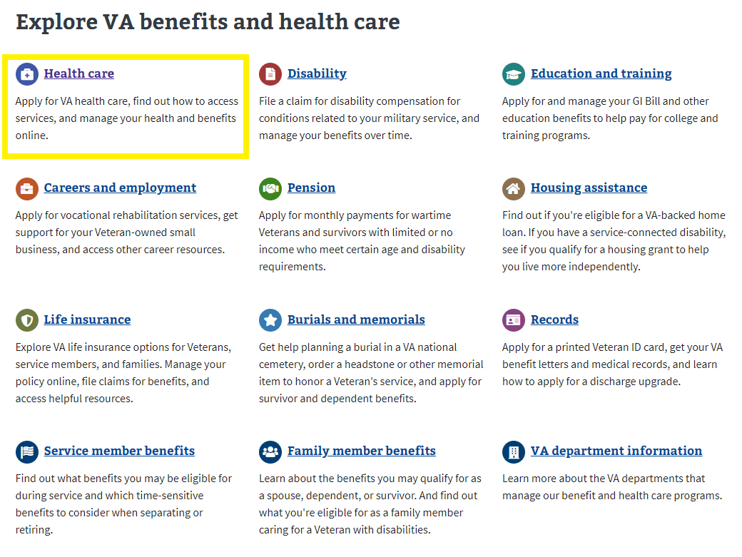

* In the health care benefit hub: <https://www.va.gov/health-care/>

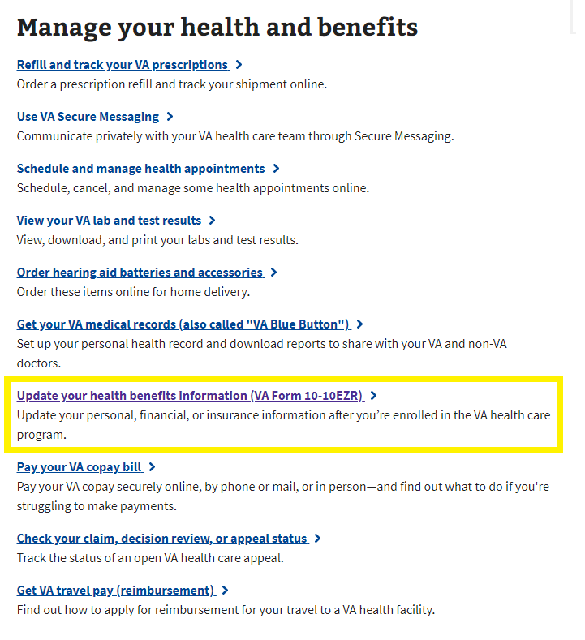

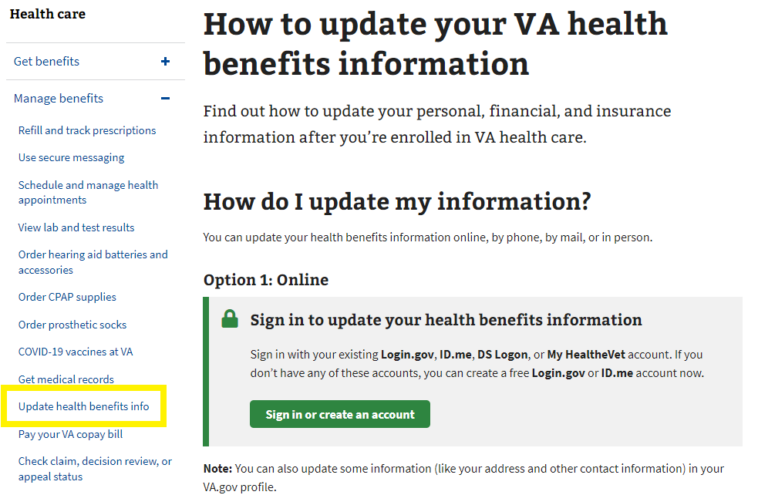

* In the My HealtheVet hub: <https://www.va.gov/my-health/>

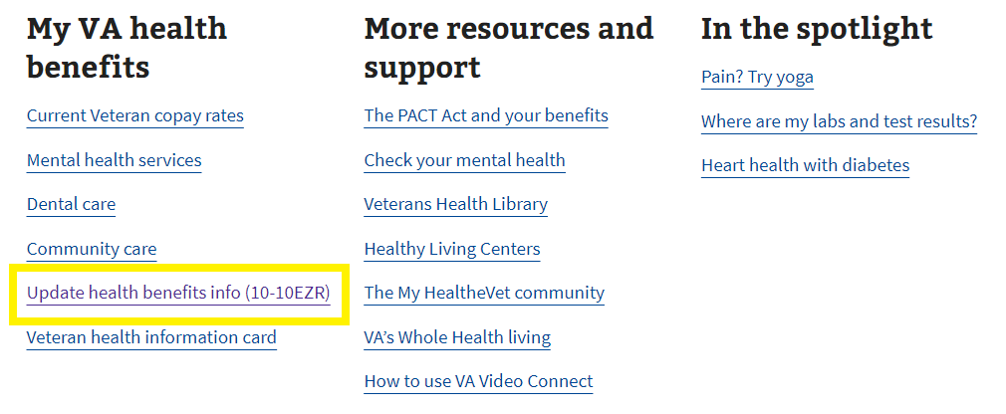

# Update Health Benefits Introduction Page

Currently, the Update Health Benefits form is available on VA.gov (https://www.va.gov/my-health/update-benefits-information-form-10-10ezr/introduction) to signed in users who come to the site and are enrolled in VA health care, whether they are LOA1 or LOA3.

For unauthenticated users, they will be prompted to sign in to update their information online.

## 

## Signed in users: LOA1 (not identity verified)

Signed in LOA1 users will see the following alert when they go to the update health benefits form introduction page at https://www.va.gov/my-health/update-benefits-information-form-10-10ezr/introduction. LOA1 users won’t be able to access the update health benefits form without first verifying their identity and becoming LOA3. This is to make sure that all users who apply are scanned through the ESR to verify whether they are or are not enrolled in VA health care.

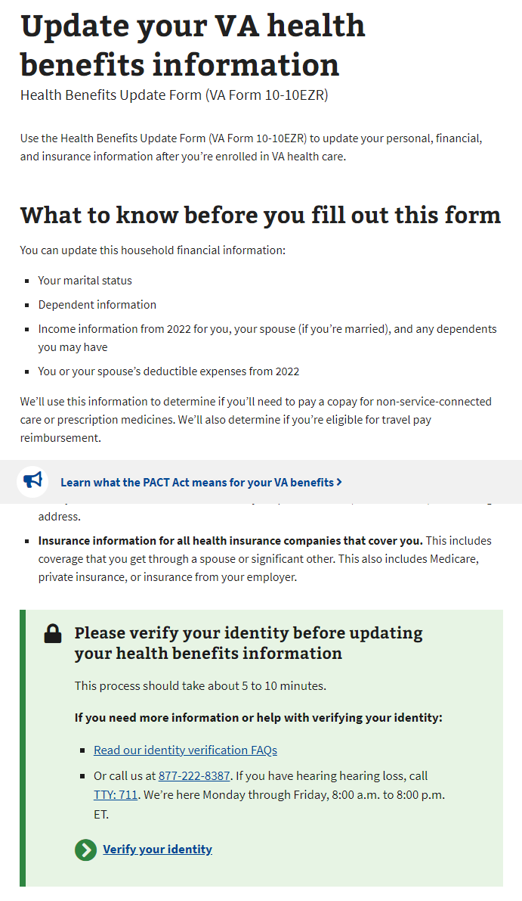

## Signed in users: LOA3 (identity verified)

For signed in LOA3 users, we will automatically perform a scan on the backend for existing health care records in the enrollment system (ESR) when they go to the form introduction page at https://www.va.gov/my-health/update-benefits-information-form-10-10ezr/introduction

For users who are not found in the enrollment system (ESR), they will not be able to go straight into the update health benefits form, and instead will see a message and be advised to apply for health care with a link to the Veteran health care application (10-10EZ):

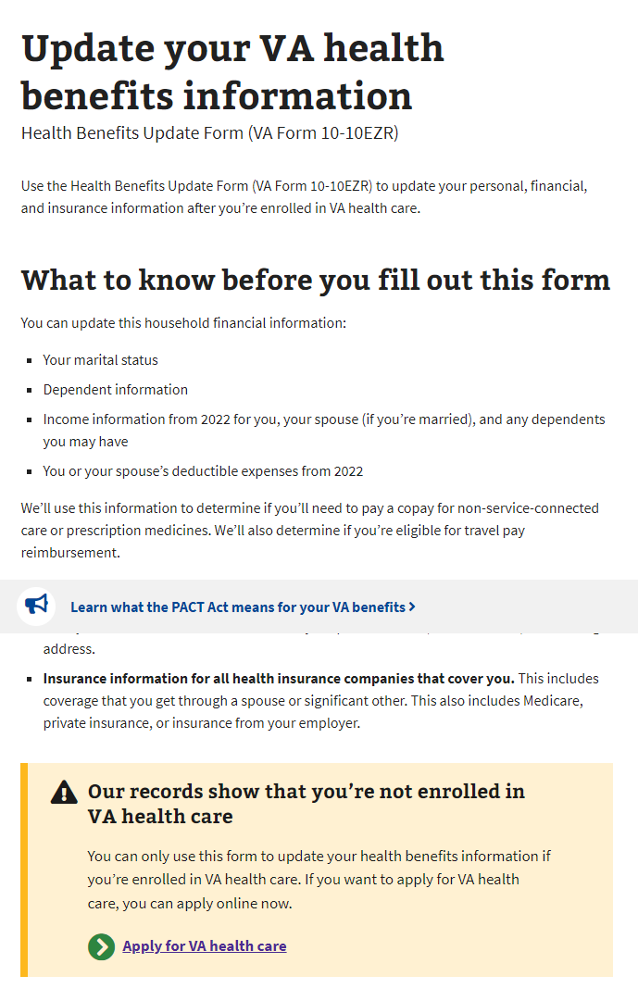

For users who are found in the ESR, they will enter into the update health benefits form.

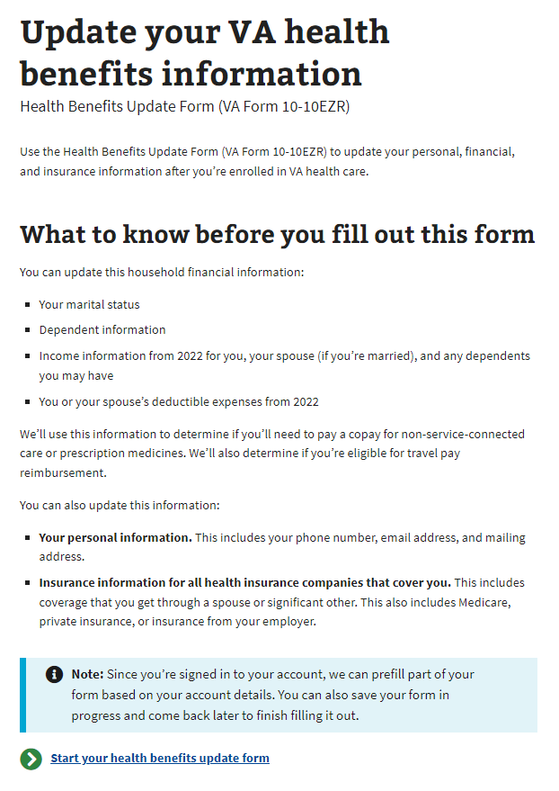

# Filling Out the update health benefits form

There are 4 sections in the update health benefits form:

1. Veteran information
2. Household information
3. Insurance information
4. Form review

Please note: The system will prefill the information we already have on file. The user will have the ability to review and update some of this as they complete the form.

Each section has multiple pages of questions that the user must enter to complete the form. The form is automatically saved as the user completes the form, and they have the option to “Finish this form later.”

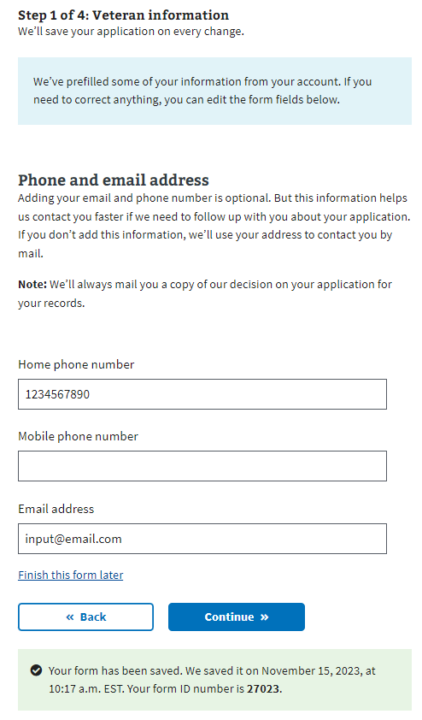

To move forward through the form, the user clicks “Continue.” They will not be able to move forward until all required information on the page is complete. An example error message is shown below. To go back to a section of the form, the user can use the back button.

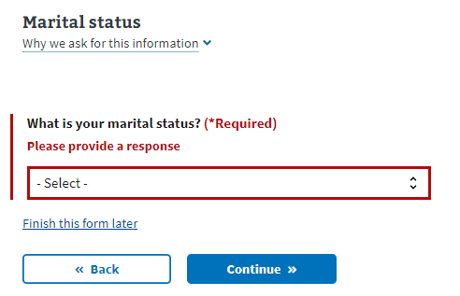

The form also has a status bar at the top of each page of the form to indicate how far along in the form a Veteran is. It progresses when a new section is complete, not based on the number of questions completed:

## 

## 

## Veteran Information

### Veteran information page 1: Names

Users are shown their name, DOB, and Social Security number in a locked state. If they need to update this information, they will need to contact the VA Benefits Hotline at 800-827-1000.

Authenticated user

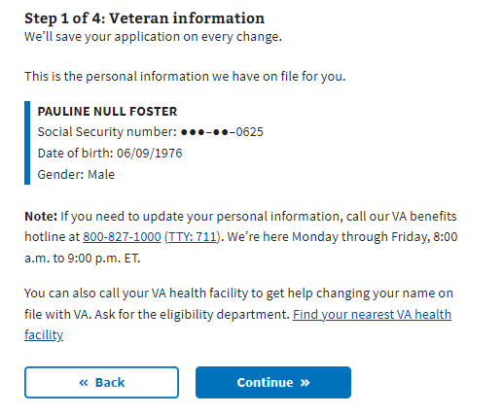

### Veteran information page 2: Mailing address

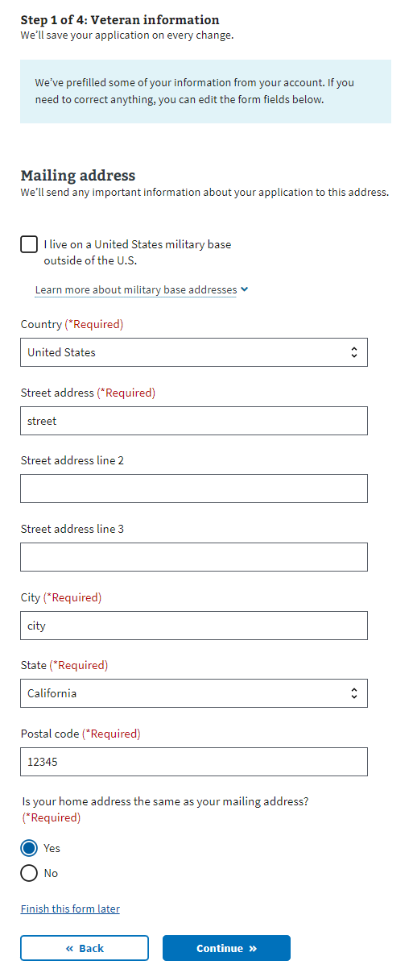

Note: If the user indicates that their mailing address is different from their home address, they will be asked to enter their home address on the following page.

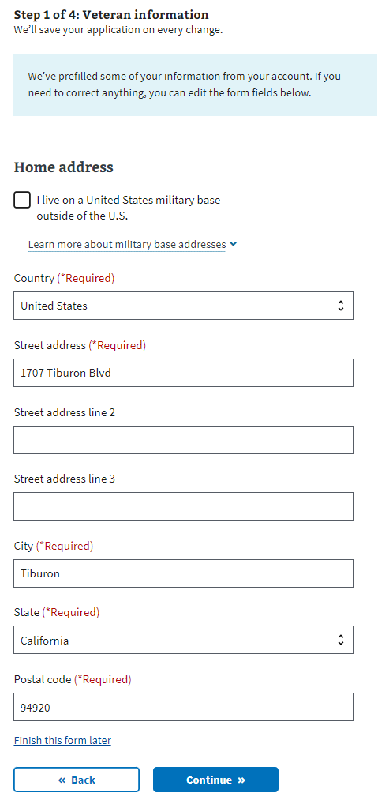

### Veteran information page 3: Email and phone number

Users may choose to provide their email address and/or home/mobile telephone numbers. If the user decides to share this information, these contact methods will be used to communicate with the Veteran during the form process. If they do not provide either, all communication will be delivered to their mailing address via paper mail.

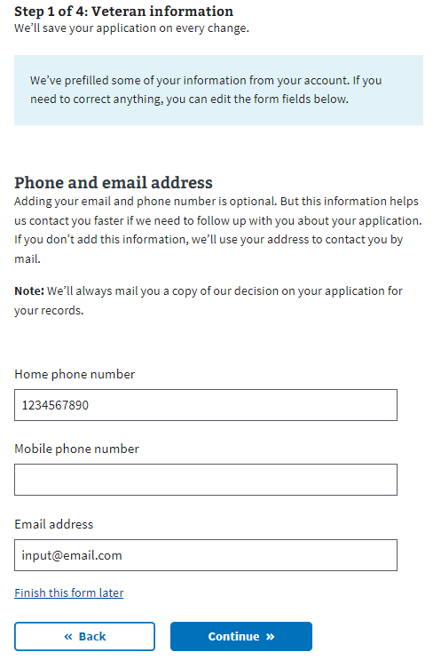

## Household Information

### 

### Household information page 1: Marital status

The user will now need to indicate their marital status from the drop-down.

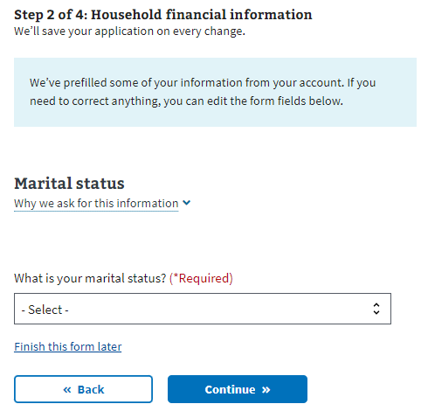

### Household information page 2: Spouse’s personal information

If the Veteran has indicated they are married or separated, they will be required to fill out their spouse’s information.

If they have indicated that they have never married, are divorced or widowed, they will be taken to the insurance information section of the form.

### 

### Household information page 3: Spouse’s additional information

The Veteran will be asked whether their spouse lived with them during the previous year, and whether they live with them now. This will help determine whether the spouse should be considered a dependent.

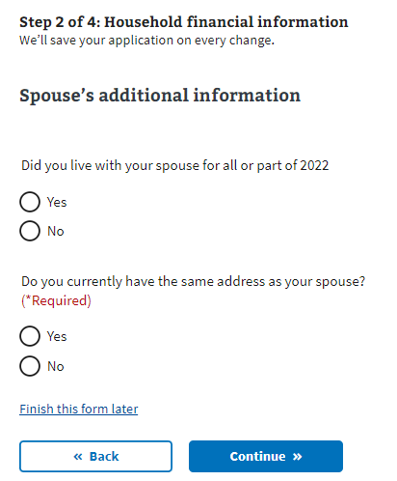

### Household information page 4: Spouse’s financial support

If the Veteran indicates that they did not live with their spouse any time in the previous year, they will be asked whether they provided financial support to their spouse during that time.

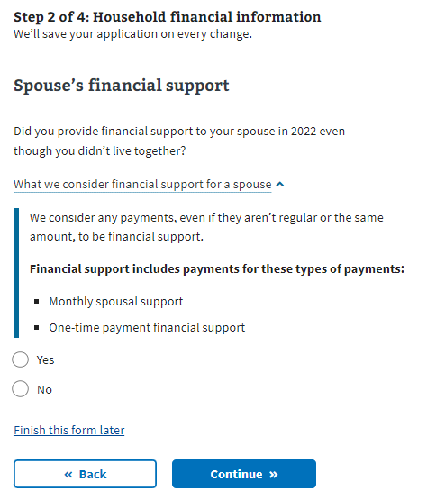

### Household information page 5: Dependent’s information

If the Veteran wants to add their dependent, the form will ask them to input information about the dependent. They will have the option to enter more than one dependent.

Examples of when someone becomes your dependent:

* **Birth of a child**: The DOB would be the date on which the child became your dependent.
* **Adoption**: The official date of adoption would be the date on which the child became your dependent.

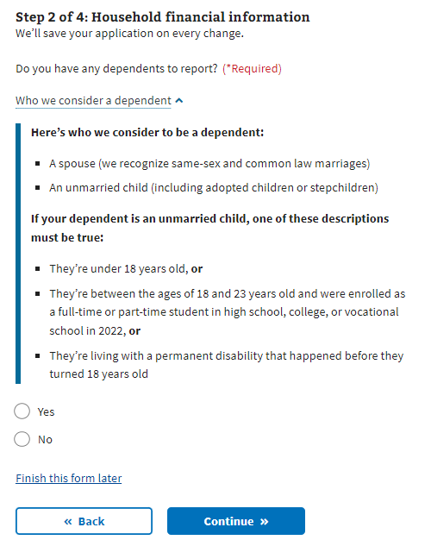

### Household information page 6: Dependent’s personal information The Veteran will be asked to provide the dependent’s information. All required fields within the dependent information pages must be completed before the form can be saved. If the Veteran exits the form before completing all required fields for the dependent, the data will not be saved and the Veteran will have to re-enter all information.

### Household information page 7: Dependent’s education expenses

If the dependent is between the ages of 18 and 23 years old, the Veteran will be asked about education expenses.

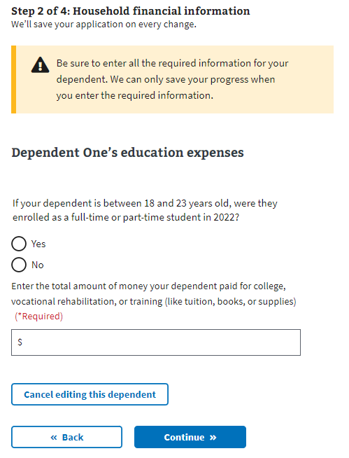

### Household information page 8: Dependent’s additional information

The Veteran will be asked whether their dependent was permanently disabled before turning 18 years old, whether they lived with them during the previous year, and if the dependent earned any income in the previous year.

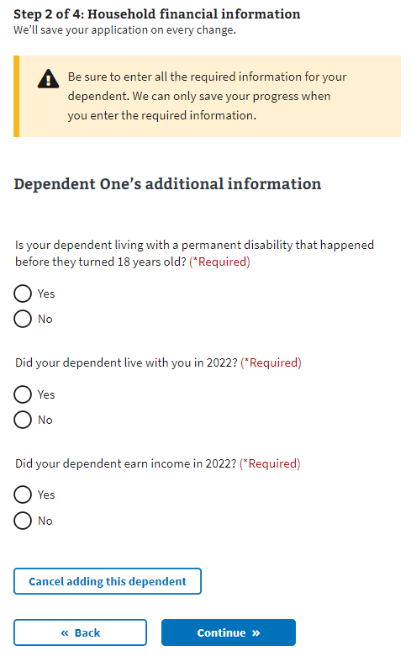

### Household information page 9: Dependent’s annual income (previous year)

If the Veteran indicates that their dependent earned income during the previous year, they will be asked for the income details.

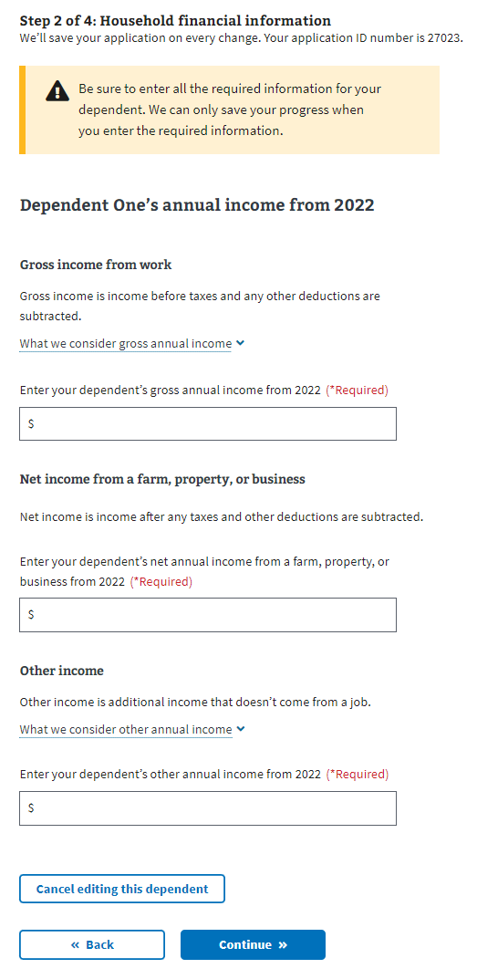

### Household information page 10: Review your dependents

Once the user has entered at least one dependent, they will see their dependent listed and be able to edit or remove the information. The user can add additional dependents by answering “Yes” to the question “Do you have another dependent to report?”  
  
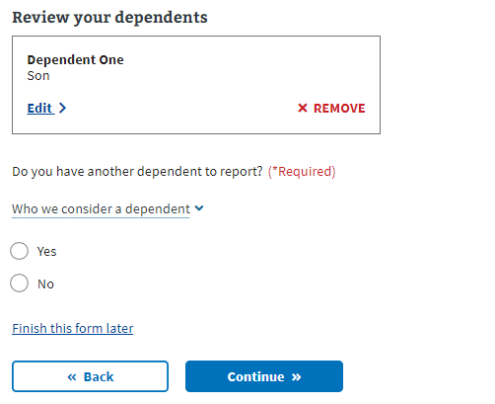

### Household information page 11: Annual income

The user will need to provide the requested financial information in the following forms. The form will ask about their annual income and their previous year’s deductible expenses. If the Veteran indicated they were married, they will also be asked for their spouse’s annual income.

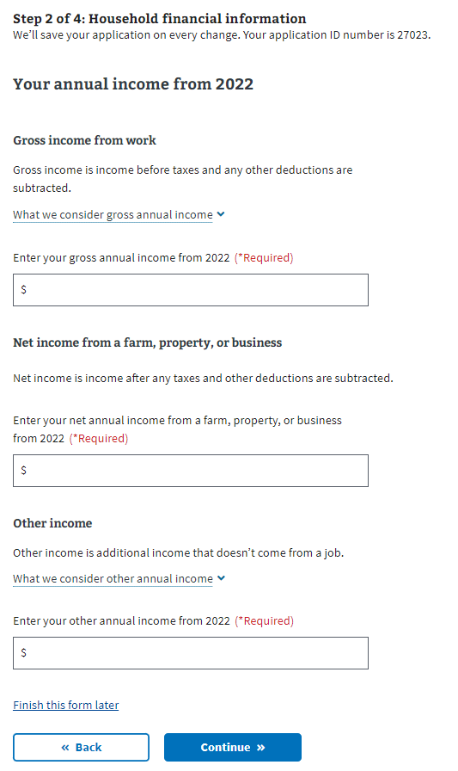

### Household information page 12: Previous calendar year’s deductible expenses

### 

## Insurance Information

### Insurance information page 1: Medicaid

All users are shown this page. The user needs to indicate whether they’re eligible for Medicaid.

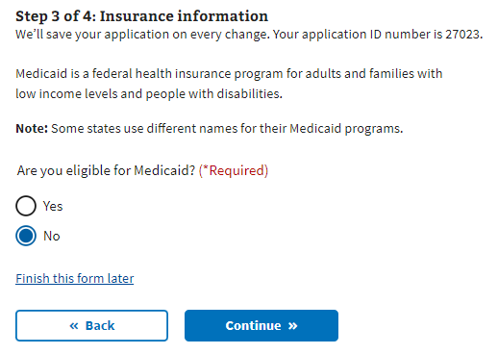

### Insurance information page 2: Medicare

The user needs to indicate whether they’re enrolled in Medicare Part A. If they select “Yes,” the next page will request the effective date of their Medicare Part A coverage.

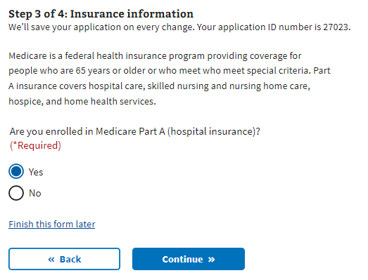

### 

### Insurance information page 3: Medicare detail

The user will need to input the effective date of their Medicare Part A, and their Medicare claim number.  
  
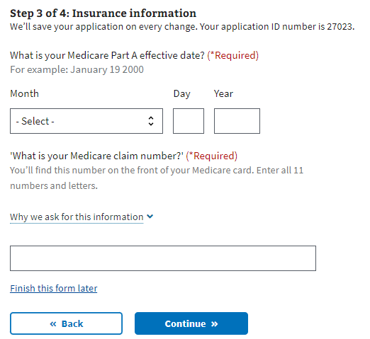

### Insurance information page 4: Other coverage

The user needs to indicate whether they have any additional health insurance coverage. If they do, the user can select Continue to the next page where they can input that information.

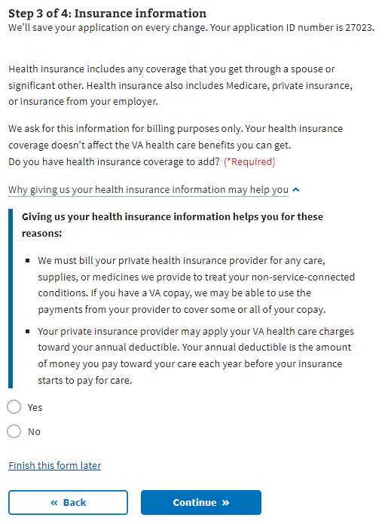

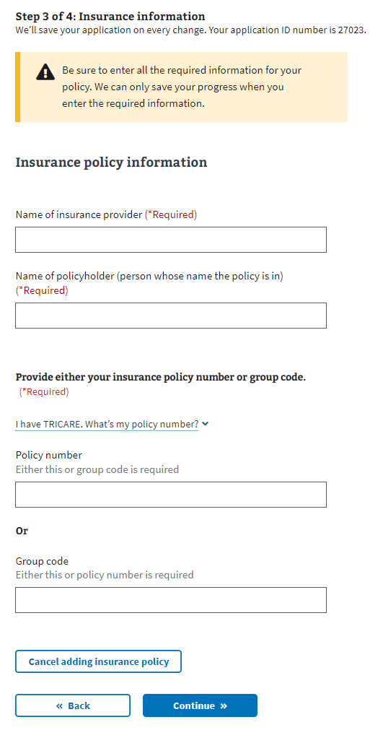

Once the user has entered at least one insurance policy, they will see their insurance policy listed and be able to edit or remove the information. They will have the option to enter more than one insurance policy.

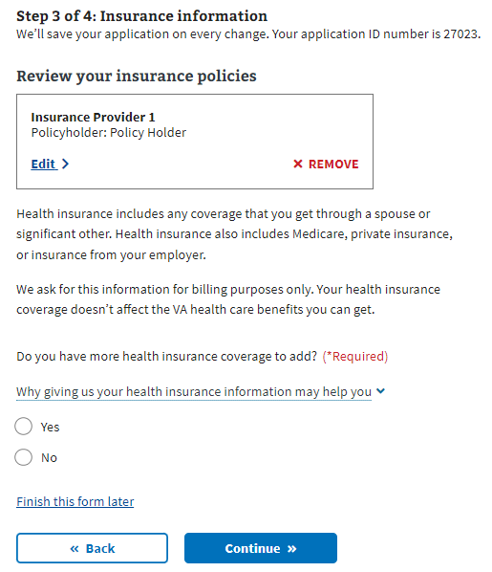

## Review form

Once the Veteran has completed the form, they will be shown the Review form section. In this section, the user can open each section and see what information they entered.

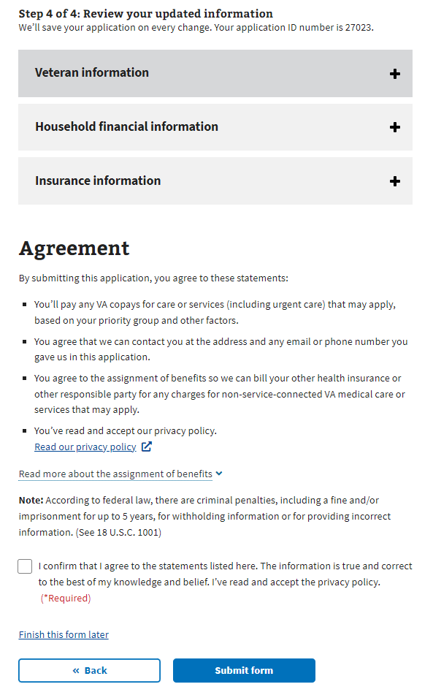

If they want to change the information shown, they can select the “Edit”button and make changes to that information.

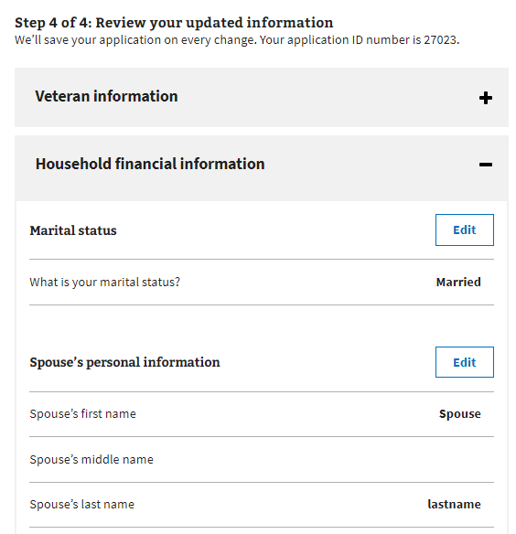

Once the “Edit”button has been pressed, the user can update the information in that section. They’ll need to make sure to press the “Update Page” button to save the changed information.

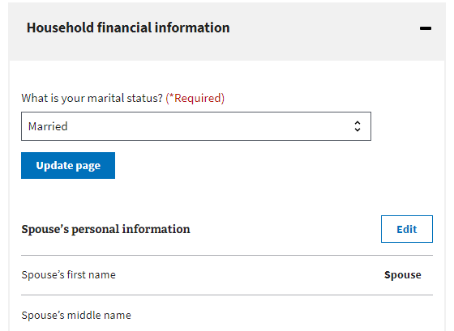

If any of the changes made remove any required information or trigger additional questions that need to be answered, the form will draw their attention to where the update needs to be made.

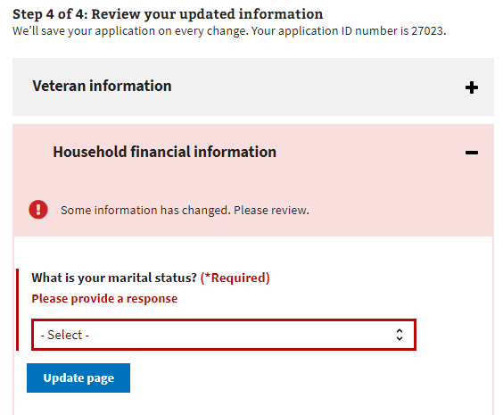

Once the user has reviewed the information and is ready to submit the form, they must select the check box indicating they agree to the statements listed, that the information is true and correct and that they have read and accepted the privacy policy. The privacy policy can be accessed via the link. This will be opened in a new tab and their form won’t be interrupted:

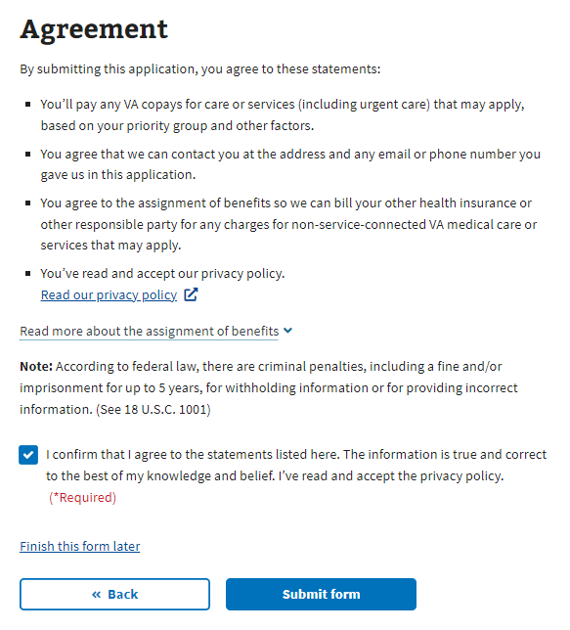

The user will be shown the following information after they submit their form:

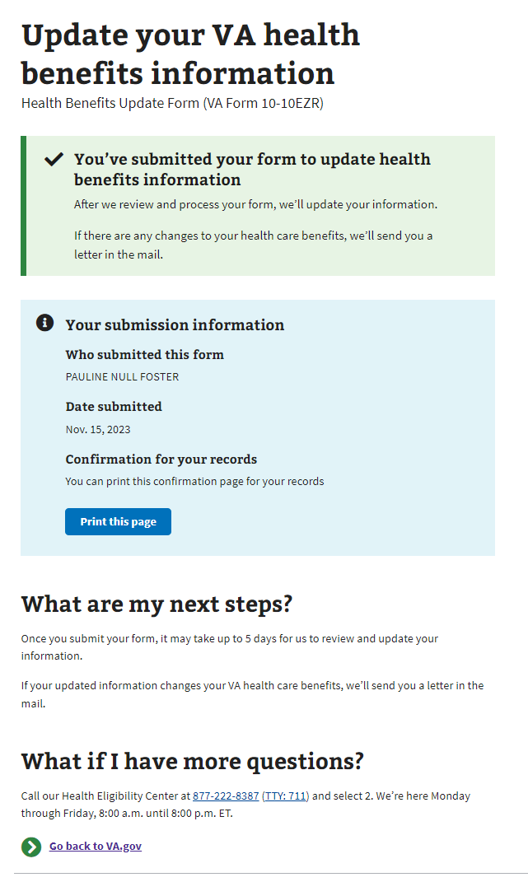

# Update health benefits form Issues

## Questions about the content of the form

Many Veterans will have specific questions about the content of the form because they don’t understand what the form is asking or why it needs that information. These are non-technical issues and should be directed to the Health Enrollment Center (HEC). Before transferring the Veteran to this call center, make sure they don’t have any questions related to the navigation or issues entering information for technical reasons.

The information for the HEC is at the bottom of every page in the update health benefits form:

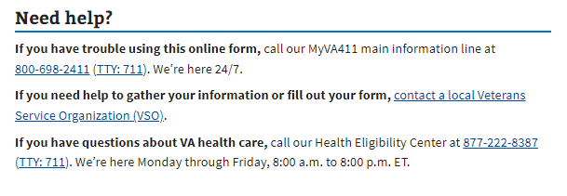

## Form is prefilled with incorrect information

If a Veteran has already entered information about themselves or their account has personal, contact, or spouse information associated with it, that information will be used to prefill the form. The purpose is to make it easier for the Veteran to complete the form. Sometimes this information is incorrect, and it may confuse the Veteran. They can fix this by editing the information directly in the form.

## Veteran Can’t Move Forward In Their form

If a Veteran is saying they can’t move on to the next page in the form, ask them to check and make sure they have filled out all the required information. The website will have a big red message indicating where it is missing required information:  
  
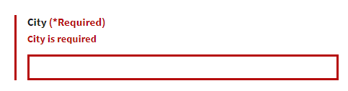

## Veteran is Having Trouble Upgrading Account From LOA1 to LOA3

If a Veteran is trying to apply for health care benefits with their LOA1 (not identity verified account), they will be required to upgrade to an LOA3 (identity verified) account. They can do this using ID.me, Login.gov, or by upgrading their My HealtheVet or DS Logon account. If the Veteran does not want to do this, you can also tell them they can update their information over the phone or in-person at their facility.